OLITECH EGYPT

Total Security Solutions

Copyright © January 2006 by
Olitech-Egypt

All rights reserved. Every effort has been made to make this document as complete and as accurate as possible, but no warranty or fitness is implied. Olitech Egypt and the author shall have either liability or responsibility to any person or entity with respect to any loss or damages arising from the information contained herein.

Olitech Egypt

Olitech Egypt, would like to thank you for giving us the opportunity to Propose our Company services offer to your honorable organization.

We hope our proposal meets your satisfaction

Please do not hesitate to contact us if any further clarifications are required.

Olitech Egypt:

Is an Egyptian company specialized in the field of Physical Security Solutions.

Olitech Egypt is an Authorized Distributor for SAMSUNG CCTV (KOREA) Solutions in Egypt.

Olitech Egypt is an Authorized Agent for IDTeck (Korea) Access Control & Time Attendance Systems in Egypt.

Olitech Egypt is the Authorized Exclusive Agent for OLIVETTI PR2 (Specialized Banking printer - ITALY) in Egypt.

Olitech Egypt is early founded to play its affective prominent rule in the Egyptian market.

Olitech Egypt's strengths and advantages come from the Quality of Equipments, Services provided, skills, experience, executive team and its solid financial backing.

Scope of our Customers:

- Almaza Airport.
- Pharmasia (Networked Proximity Cards Access Control System).
- Laundbek (Networked Finger Print Access Control System).
- Sarydar (Networked Proximity Cards Access Control System).
- Shaker Consulting Group (Networked Proximity Cards Access Control System).
- CIB Bank (Networked ATM Cards Access Control System for the ATM Hall).
- Piraeus Bank
- Delta Bank
- Blom Bank
- Al Arabia Company for Insurance.
- Al Rasheedy Al Mizaan.
- Artoc Group.
- Dar Al Fouad Hospital.
- Al Sherouk Hospital
- Oriental Petrochemicals.
- Abo Ghaly Motors
- El Sokhna Port.
- NISSAN Modern Motors
- Mobil.
- Shell.
- Al Gendy Co. (Stand Alone Proximity Cards Access Control System).
- PolyServe Co.
- AgreenServe Co.
- Advechems Co.
- Afofoco
- Quicktel
- Global Brands
- Metito Constructions

Our Objective:

We aim to provide our valued customers with the highest quality of value added Security System solutions In Three major lines of services Olitech Egypt is presenting:

Olitech Egypt

Access Control
Time Attendance
CCTV

- Fixed Cameras  - PTZ Cameras  - Speed Dome  - Zoom Camera  - IP Based Cameras  - Special Proposes CCTV Solutions  - Recording | - Face Recognition.  - Finger Print  - Smart Card  - Proximity Cards  - Car Park Access Control System.  - Lift Access Control System.  - Long Range Readers up to 5M  - CCTV Integration | - Finger Print / Proximity solutions that covers:  - Time Attendance only.  - Single Shift  - Multiple Shift and cross overnight shift  - Time Attendance c/w Security Access Control  - Payroll Software Based on Oracle

Why to use Access Control System?  Eliminates identity fraudulence in unauthorized access.  Controlling Access to the safe house.  Logging Access for the safe house.  Controlling WHO can access WHERE and WHEN.  Providing a systematic identification mechanism. | Why to use Time Attendance Management System?  “Very Simple” cause Time = Money so loosing time is loosing money.  Saves wasted money, no more human errors, no more excuses.  Automate the exhausting time collection process, which saves time, and become more accurate.  Reporting are made easy with the customized and flexible reports for both high level reports for top managers and deep detailed report for executives.  Employees performance measurement.  Centralized and distributed management for the HR to ease for the management, and provide an overview of the whole organization behavior, with the ability to trace down to more details very easy very flexible and in a very short time.

What else we can afford for you??

Solution Consulting
We work closely with you to determine the right solution for your needs, ensuring that the solution is Suitable, Cost Effective, Secure, and Easy to use.

System Training
The company also may present a customized training about all items to teach employees how to use the System, The company objective is extended to match all your needs.

Maintenance
We have an authorized center with a professional team that can provide Periodical maintenance for companies and establishments without or including spare parts.

Total Security Solution
Configuration
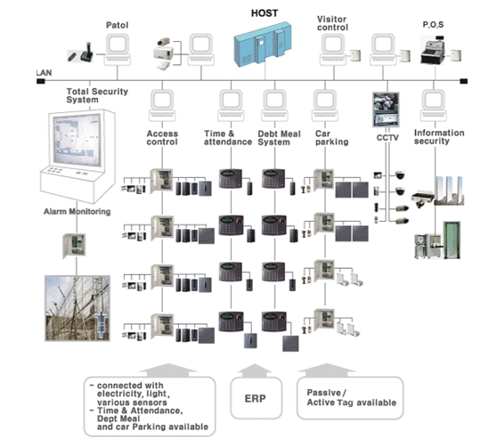

Checklist for System Configuration

Configuration | Check Point
Object | Select the system which will be operated totally
Operation | Select how and who will operate the system
User and Manual | Check the actual users and user's manual
Capacity | Check the capacity of all related parties (manufacturer, installer, contractor, etc)
Basic Data | Data which will be used to operate the system
Event Data | Data which is created upon system operation
Data Management | How to manage and save data (RDBMS, DBMS, general file, etc)
Network | Network which is supported by the system  (LAN, RS232C, RS422, RS485, Fiber Optic, etc)
System Protocol | Protocols used in the system (TCP/IP, UDP, IPX/SPX, etc)
User Protocol | The promise in program to connect each data
Interface | Interface to be used for data transmission
Data usage | Usage of related data and select the range/object of application program
Data backup and reliability | Emergency operation in case of system down and all related systems must  be stabilized

Checklist for System Interface

Configuration | Check point
Security System | - Personal tracking and collect data who is in the room  - Control access door (Remote Open / close, Open / Close always )  - Anti pass back  - Duress mode
Fire Protection | - System and controller interface  - Select restrict area  - Object : Fire, Gas, water leakage, etc  - Output : alarm, bell, lamp, siren, etc
Building Automation | - Control : Power, Light, etc  - Select restrict area
System | - Communication (LAN, RS232C, RS422, etc)  - User Protocol
Human Resource Management | - Data collection  - Communication (LAN, RS232C, RS422, etc)  - Data connection (S/W, DB connection)  - Set User protocol  - Interface
Parkingsystem | - Interface  - Communication (LAN, RS232C, RS422, etc)  - User Protocol
CCTV system | - Equipment capacity  - Set restrict area and coding  - Interface  - Various sensors and control light

Access Control
The Standalone System
This is the most cost effective solution for access control system only and 512 card holders can be registered.
System can be operated by various modes such as RF card, PIN or RF card + PIN.
Optionally, user can adopt software to collect data via RS232C
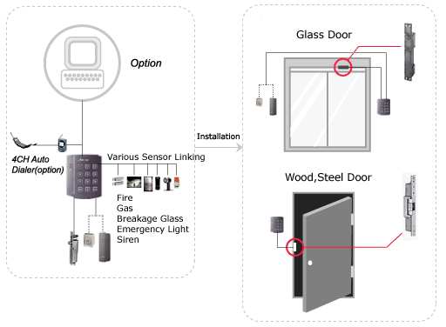
Network System

The most of products are expandable up to 32EA and it allows users to control remote site as well.
Time schedule and Group can be set to achieve high security control. Program allows to control all functions and
collect data in real time. All imaginations from customers can be real.
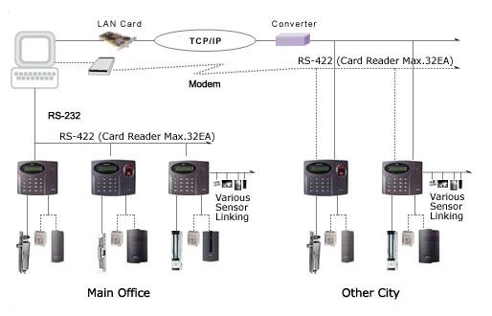

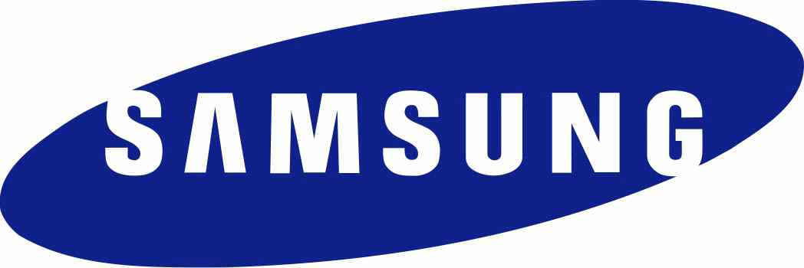

IP cameras technology

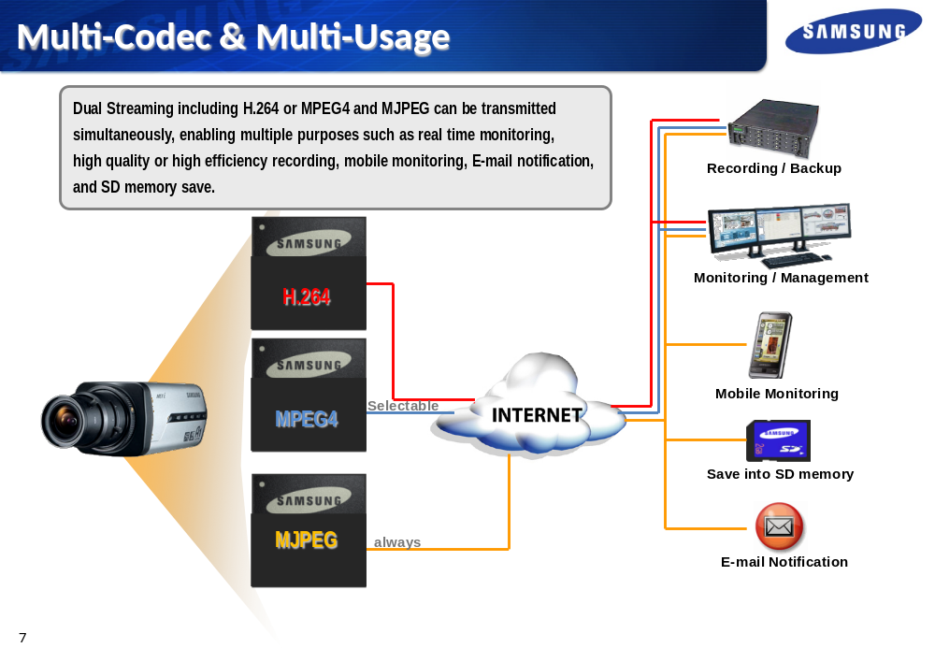

Conventional CCTV system

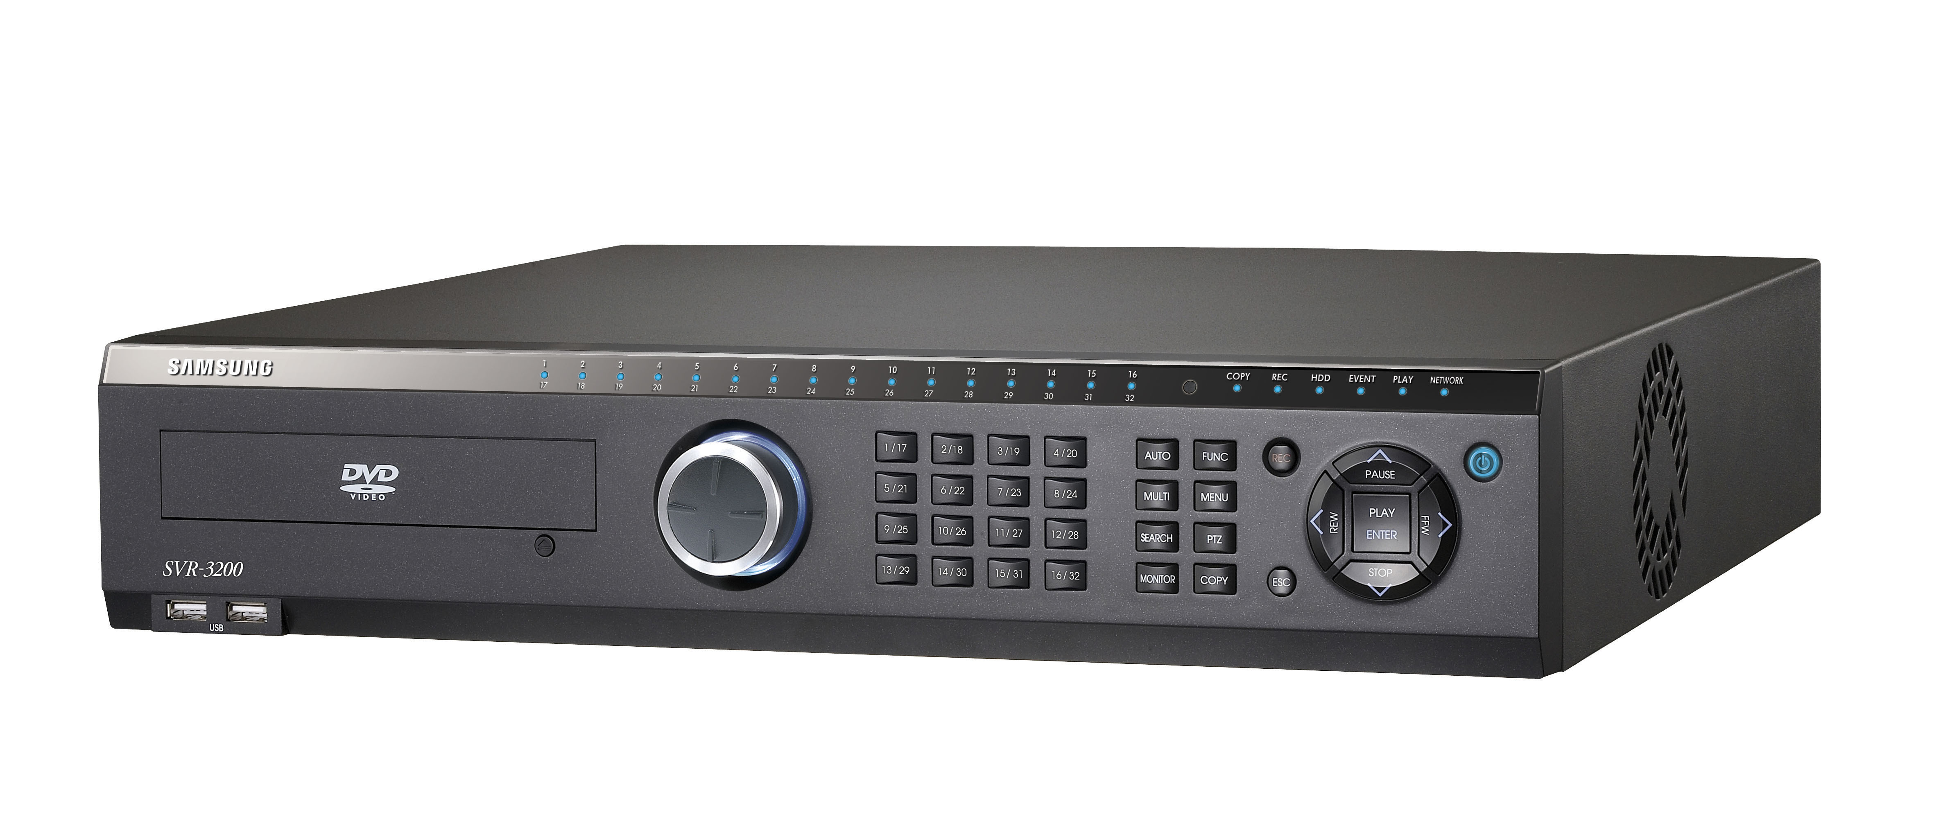
Samsung Conventional system is the perfect choice for medium to large businesses. The SVR-3200 provides 32 channels of high resolution real-time video recording capability at half D1 (704 x 240) resolution. The SVR-3200 allows the user to customize the recording setting to achieve real-time full D1 (704 x 480) resolution on selected channels. The SVR-3200 also comes with network monitoring software which allows the user to have remote access and control of the DVR over the network.

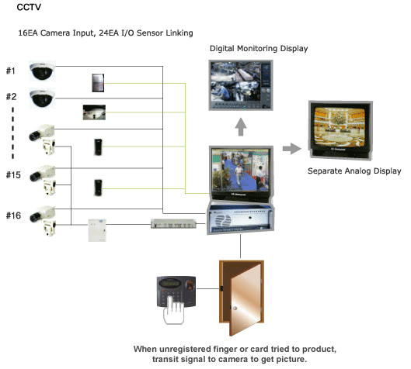

Car Park

Long Range Distance(Active)
Long range reader and tag in parking system give less irritations cause from unnecessary acts such as open the window to present card when customer enters the parking lot. Active tag has about 5 year life time and read range is adjustable up to 2.1 m.
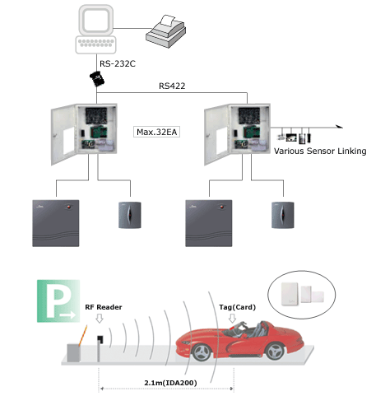

  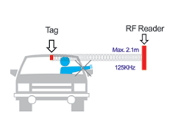
  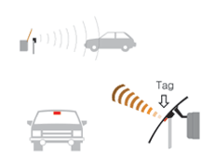

Time & Attendance

Time& Attendance/Factory
This standalone system can be applied for Time & Attendance system with Function keys on it. Function keys allow user to define various time & attendance situations such as attendance, leaving, and so on. Even user lost their RF card, they are able to access with personal PIN number.
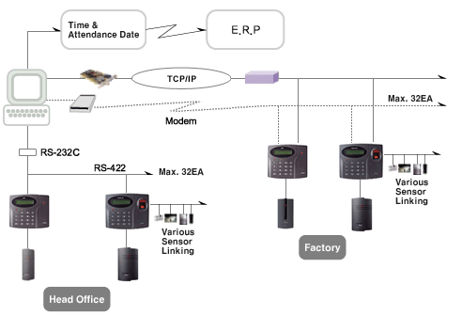

Management Software

Video monitoring and management function integrated with access control system
- Dual monitors support

KEY Features

Video monitoring and management function integrated with access control system"
Dual monitors support
Multi-channel display (1,2,4,6,8,9,12 and 16 channel monitoring available)
Record user defined pre-alarm recording time
NTSC and PAL camera support
Control and monitoring via web (built-in Web Server)
Surperpowered access control software by perfect integration with video surveillance"
Support exclusive image player linked with event log information

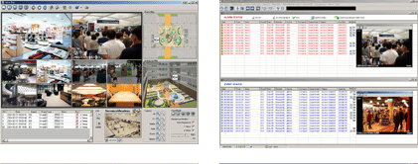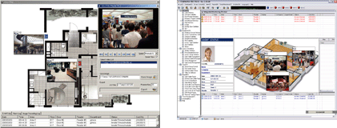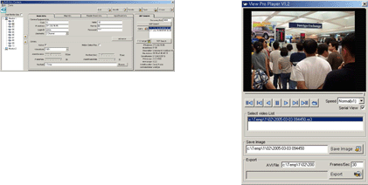

Available Device

Web Server | WP101(1 Channel), WP106(6 Channels) /  FW3110(1 Channel), FW3440(4 Channel)
Camera | Normal CCTV Camera Avaliable

Installation Enviroment

CPU | Pentium IV or Higher
Memory | 512 MB or Higher
Hard Disk | 20GB or Higher
Operating System | Windows 2000 Professional, Server/Windows XP Home and Professional/Windows 2003 Server

ID BADGING System
- Compatible with various card printer including Eltron and Fargo
- Easy card design tool
KEY Features

Compatible with various card printer including Eltron and Fargo
Easy card design tool
Batch card issuing available based on database
Image capturing from PC camera and digital camera
Card issuing history report
Image Editor tool
Print preview
Integrated card holder management

Installation Enviroment

CPU | Pentium III or Higher
Memory | 256 MB or Higher
Hard Disk | 10GB or Higher
Operating System | Windows 2000 Professional, Server / Windows XP Home, Professional / Windows 2003 Server

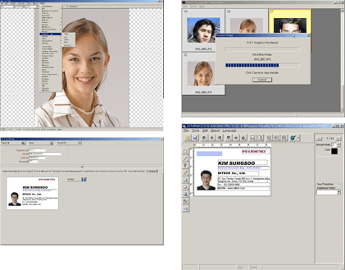

THANK YOU

